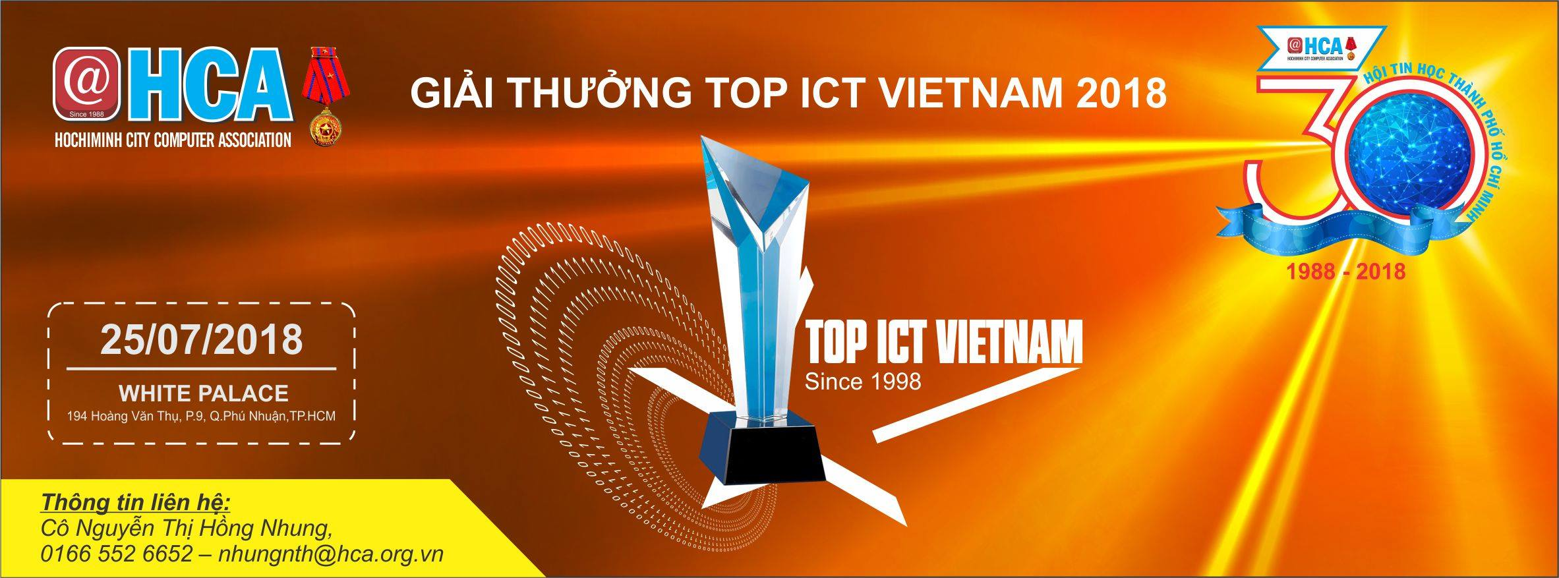

VIET NAM TOP ICT AWARD 2018 REGISTRATION FORM
INFORMATION TECHNOLOGY – TELECOM ENTERPRISES SUCCESSFULLY START UP
(Group 12)
*For IT-TELECOM ENTERPRISES FOUND UNDER 5 YEARS OLD (till the end of 2017)*

A. General Information
- Company’s name:
- Trading name:
- Address:
- Phone:
- Fax:
- Email:
- Website:
- Business registration certificate:
- Floating date:
- Branch/ Representative office:
- General Manager/ Director:
- Main business sector:
- Main product:
- Main market:
- Number of employees: 2014: 2015: 2016: 2017: Turn-over for 2 years: 2016: 2017:
- The quality certificates:
- The awards have been achieved:
B: PRODUCT / SERVICE / SOLUTIONS’ S DETAILS :
NAME product /services /solutions:
- product /services /solutions: New 100% O Upgrade from old product O
If it was upgraded, please note which (whose) product/ services/ solutions that you do upgrades from?

- Starting time to hit the market:
- Ratio of localization in hardware:
- Ratio of localization in software/ embedded system:
- Ratio of localization in establish service/ solution for customer:
- The origin of the product/ services / solutions:
- Copyrights on design design / industrial designs: Yes O No O
If its yes, please note the certificate:
- Certificate of copyright / intellectual property for each product / service / solution

- Awards have been achieved:
- Targeted customer:
- Number of customers who have been using products/ sẻvices:
Name some typical customer (can be assessed):

- Warranty system/ after sale supporting:
Online:
Offline:

C. Introduce about product/ services/ solutions (Short description for 200 words about technology used, application field and objects used)

(It’s ok to send with document/ Catalog)

D: Introduce about results that business achieved and plan to develop both the compay and and product/ services/ solutions:

E: Target in the next years:
Open more branches/representative office:
      - Add more services:
      - Expanding market share:
      - Expanding market: Domestic O Foreign O

F: What companies want the State management/ association to support enterprises to develop in the next years:

Day Month Year 2018
Business representative
Sign and seal

** Note: -Photocopy notarized license established/ business registration / tax code enclose the file

Copies of the financial report for 2017 (certified by the enterprise)
The Organizer is committed to keeping this information confidential and is only available for consideration.

